Python OOP Retake Exam - 14 August 2024
Link to Judge
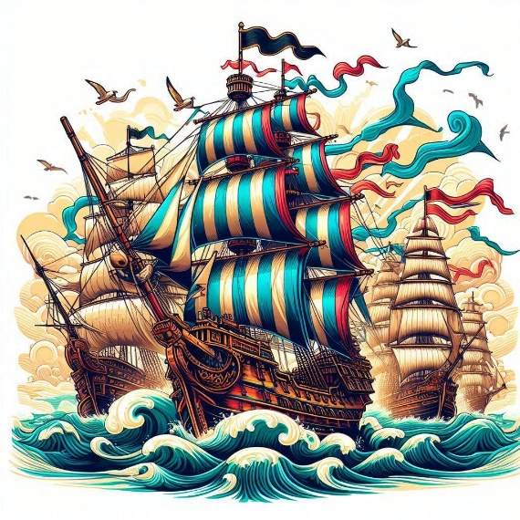
Welcome to the BattleZones simulation system, where Royal and Pirate Battleships engage in strategic combat within designated battle zones. Each battle zone, whether a Royal Zone or Pirate Zone, hosts battleships, each with defined attributes and behaviors. Manage these zones and battleships through a centralized Battle manager, ensuring thrilling and tactical warfare.

You are provided with a skeleton that includes all folders and files you need.
Note: You are not allowed to change the folder and file structure or change their names!
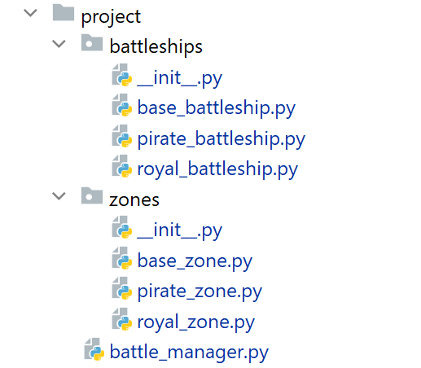
Judge Upload
For the first two problems, create a zip file with the project folder and upload it to the Judge system.
For the last problem, create a zip file with the test folder and upload it to the Judge system.
Do not include in the zip file your venv, .idea, pycache, and __MACOSX (for Mac users), so you do not exceed the maximum allowed size of 16.00 KB.

Structure (Problem 1) and Functionality (Problem 2)
Your task is to implement the structure and functionality of all classes (properties, methods, inheritance, abstraction, etc.)
You can add additional attributes (instance attributes, class attributes, methods, dunder methods, etc.) to simplify your code and increase readability if it does not change the project's final result following its requirements and proper workflow.

Class BaseBattleship
In the base_battleship.py file, the class BaseBattleship should be implemented. It serves as a base class for any type of battleship and should not be instantiated directly.

Structure
The class should have the following attributes:
- name: str
  - The value represents the name of the battleship.
  - The name should contain letters only, if not raise a ValueError with the message: "Ship name must contain only letters!"
- health: int
  - The value represents the health of the battleship.
  - If the health drops below 0, set it to 0.
- hit_strength: int
  - The value represents the damage the battleship inflicts.
- ammunition: int
  - The value represents the ammunition of the battleship.
- is_attacking: bool
  - The value determines whether the ship is attacking or being attacked.
  - The initial value is set to False.
- is_available: bool
  - The value determines whether the ship is currently participating in a battle.
  - The initial value is set to True (not participating).

Methods

__init__(name: str, health: int, hit_strength: int, ammunition: int)
- In the __init__ method, all the needed attributes must be set.

take_damage(enemy_battleship: BaseBattleship)
- When the ship is attacked, it takes damage (decreasing health) equal to the hit strength of the attacking enemy ship.

attack()
- When the ship attacks, its ammunition decreases. Each type of battleship implements this method differently.

Class RoyalBattleship
In the royal_battleship.py file, the class RoyalBattleship should be implemented. The Royal Battleship is a type of BaseBattleship. Each Royal Battleship initially has 100 units of ammunition.

Methods

__init__(name: str, health: int, hit_strength: int)
- In the __init__ method, all the needed attributes must be set.

attack()
- The method reduces the Royal Battleship's ammunition amount by 25 units. If the value drops below zero, set it to zero (0).

Class PirateBattleship
In the pirate_battleship.py file, the class PirateBattleship should be implemented. The Pirate Battleship is a type of BaseBattleship. Each Pirate Battleship initially has 80 units of ammunition.

Methods

__init__(name: str, health: int, hit_strength: int)
- In the __init__ method, all the needed attributes must be set.

attack()
- The method reduces the Pirate Battleship's ammunition amount by 10 units. If the value drops below zero, set it to zero (0).

Class BaseZone
In the base_zone.py file, the class BaseZone should be implemented. It serves as a base class for any type of battle zone and should not be instantiated directly.

Structure
The class should have the following attributes:
- code: str
  - The value represents the code of the zone.
  - The code must contain only digits, if not raise a ValueError with the message: "Zone code must contain digits only!"
- volume: int
  - The value represents the zone's volume (capacity).
- ships: list
  - A list containing battleships (objects) each zone has.
  - Initially set to an empty list.

Methods

__init__(code: str, volume: int)
- In the __init__ method, all needed attributes must be set.

get_ships()
- Returns a list of all battleships in the zone, ordered by ship's hit strength descending, then by ship name ascending.

zone_info()
- Returns detailed information about the zone. Keep in mind that each type of zone implements the method differently.

Class RoyalZone
In the royal_zone.py file, the class RoyalZone should be implemented. A Royal Zone is a type of BaseZone. The Royal Zone has an initial volume of 10 ships.

Methods

__init__(code: str)
- In the __init__ method, all needed attributes must be set.

zone_info()
- The method returns detailed information about the battle zone, in the following format (each row on a new line):
"@Royal Zone Statistics@
Code: {zone_code}; Volume: {zone_current_volume}
Battleships currently in the Royal Zone: {battleships_total_count}, {pirateships_count} out of them are Pirate Battleships.
#{Battleship_name1}, …, {Battleship_namen}#"
- Order the ships by ship's hit strength descending, then by ship name ascending.
- Return the ship names (if any) surrounded by hashtags ('#'), separated by comma and space ', '. If there are no ships - skip the line. See the Examples
Hint: You can use the get_ships() method.

Class PirateZone
In the pirate_zone.py file, the class PirateZone should be implemented. A Pirate Zone is a type of BaseZone. The Pirate Zone has an initial volume of 8 ships.

Methods

__init__(code: str)
- In the __init__ method, all the needed attributes must be set.

zone_info()
- The method returns detailed information about the battle zone, in the following format (each row on a new line):
"@Pirate Zone Statistics@
Code: {zone_code}; Volume: {zone_current_volume}
Battleships currently in the Pirate Zone: {battleships_total_count}, {royalships_count} out of them are Royal Battleships.
#{Battleship_name1}, …, {Battleship_namen}#"
- Order the ships by ship's hit strength descending, then by ship name ascending.
- Return the ship names (if any) surrounded by hashtags ('#'), separated by comma and space ', '. If there are no ships - skip the line. See the Examples
Hint: You can use the get_ships() method.

BattleManager
In the battle_manager.py file, the class BattleManager should be implemented. It will manage the battles and interactions between ships in the battle zones.

Structure
The class should have the following attributes:
- zones: list
  - A list containing all zones (objects) assigned to host battles.
  - Initially an empty list.
- ships: list
  - A list containing all battleships (objects) intending to participate in battles.
  - Initially an empty list.

Methods

__init__()
- In the __init__ method, all the needed attributes must be set.

add_zone(zone_type: str, zone_code: str)
The method creates a zone object of the given type and code and adds it to the zones collection.
- First, check If the type is a valid one, if not valid, raise an Exception with the following message:
"Invalid zone type!"
  - Valid types of zones are: "RoyalZone" and "PirateZone".
- Then, check if a zone with the given code is already in the collection. If such a zone exists, raise an Exception with the following message:
"Zone already exists!"
- Otherwise, create the zone, add it to the zones list, and return the following message:
"A zone of type {zone_type} was successfully added."

add_battleship(ship_type: str, name: str, health: int, hit_strength: int)
The method creates a ship object of the given type with the given attributes and adds it to the ships collection.
All ship names will be unique.
- First, check if the ship type is valid: 'RoyalBattleship' or 'PirateBattleship'.
If not, raise an Exception with the following message:
"{ship_type} is an invalid type of ship!"
- Otherwise, create the ship object, add it to the ships list, and return the following message:
"A new {ship_type} was successfully added."

add_ship_to_zone(zone: BaseZone, ship: BaseBattleship)
The method adds the provided ship object to the given zone (object). The zone and ship will always exist.
- First, check if the zone has enough volume to allow the ship to participate. If not, return the following message:
"Zone {code} does not allow more participants!"
- Then, check if the ship's health is greater than zero, and if not, return the message:
"Ship {name} is considered sunk! Participation not allowed!"
- Next, check if the ship is available, and if not, return the message:
"Ship {name} is not available and could not participate!"
- If none of the above is reached, the ship can participate:
  - Check the ship type and compare it with the zone type.
    - When a ship from an enemy type participates in an enemy zone, it becomes a target:
      - Mark it as being under attack (the is_attacking value remains False).
An enemy zone/ship example: RoyalBattleship enters PirateZone or PirateBattleship enters a RoyalZone.
- When a ship from the same type enters the zone, it becomes an attacker (will attack enemy ships):
  - Mark it as an attacker (set the is_attacking value to True).
  - Add the ship to the zone's ships collection.
- Mark the ship as unavailable so it could not be added to other zones.
- Decrease the zone's volume.
  - Return the following message:
"Ship {name} successfully participated in zone {zone_code}."

remove_battleship(ship_name: str)
The method removes the battleship with the given name from the battle manager ship's collection.
- First, check if a ship with the given name exists in the battle manager ships collection. If not, return the following message:
"No ship with this name!"
- Then, check if the ship participates in a zone (is_available value). If so, return the following message:
"The ship participates in zone battles! Removal is impossible!"
- If the ship can be removed successfully, remove it from the battle manager ships collection, and return the following message:
"Successfully removed ship {ship_name}."

start_battle(zone: BaseZone)
The method initiates a battle between two of the participating battleships in the given zone (always existing object):
- First, check if there are at least two battleships: one attacker and one target (enemy, being attacked), depending on their is_attacking value. If not, return the message:
"Not enough participants. The battle is canceled."
- Battle Rules (in case there are two ships - one attacker and one target):
  - Select the most powerful battleship (based on hit strength) that corresponds to the zone in type, marked as attacker (is_attacking=True).
Example: RoyalBattleship and RoyalZone correspond in type
  - The opponent will be the healthiest enemy battleship (based on health) that does not correspond in type (marked as being attacked).
Example: PirateBattleship and RoyalZone do not correspond in type
  - Perform the battle using the appropriate methods: attack() and take_damage().
    - The attacking ship performs an attack (attack() method, decreasing its ammunition), while the enemy ship takes damage (take_damage() method, decreasing its health).
- Result:
  - First, check if the enemy ship's health drops to 0. If so, it is removed from the zone and the manager's ships collection. Return the following message:
"{ship_name} lost the battle and was sunk."
  - Then, check if the attacking ship runs out of ammunition. If so, it is removed from the zone and the manager's ships collection. Return the following message:
"{ship_name} ran out of ammunition and leaves."
  - Otherwise, both ships remain in the zone. Return the following message:
"Both ships survived the battle."
- Constraints:
  - There will always be only one ship with maximum hit strength (if any) and only one with maximum health (if any).
  - The method performs one battle per call.
  - When there is a sunk ship, the other will have ammunition left. There won't be a case when both ships shall be removed.
Note: Use the attack() and take_damage() methods to perform the battle properly.

get_statistics()
The method returns up-to-date statistics for all zones in the battles manager collection and the battleships currently available (not participating in zones).
- Return the available ship names (if any) in their current order, surrounded by hashtags ('#'), separated by comma and space ', '. If there are no available ships - skip the line.
- Order zones by zone code ascending.
- Return information for each zone, generated by its designated method zone_info().
- The output string should contain the above-described information, on new lines as follows:
"Available Battleships: {available_ships_count}
#{available_ship_name1}, …, {available_ship_namen}#
***Zones Statistics:***
Total Zones: {zones_count}
{zone1_info}
…
{zonen_info}"
- Note: Use the zone's zone_info() method to generate the statistics properly.

Examples
Test Code
# Initialize the BattleManager
battle_manager = BattleManager()

# Add zones
print(battle_manager.add_zone("RoyalZone", "001"))
print(battle_manager.add_zone("PirateZone", "002"))
print()

# Add battleships
print(battle_manager.add_battleship("RoyalBattleship", "RoyalOne", 50, 50))
print(battle_manager.add_battleship("RoyalBattleship", "RoyalTwo", 80, 45))
print(battle_manager.add_battleship("PirateBattleship", "PirateOne", 50, 50))
print(battle_manager.add_battleship("PirateBattleship", "PirateTwo", 70, 60))
print(battle_manager.add_battleship("RoyalBattleship", "RoyalThree", 100, 100))
print(battle_manager.add_battleship("PirateBattleship", "PirateThree", 90, 90))
print()

# Retrieve battleships and zones
royal_zone = battle_manager.zones[0]
pirate_zone = battle_manager.zones[1]

royal_one = battle_manager.ships[0]
royal_two = battle_manager.ships[1]
pirate_one = battle_manager.ships[2]
pirate_two = battle_manager.ships[3]

# Add ships to zones
print(battle_manager.add_ship_to_zone(royal_zone, royal_one))
print(battle_manager.add_ship_to_zone(royal_zone, pirate_one))
print(battle_manager.add_ship_to_zone(pirate_zone, royal_two))
print(battle_manager.add_ship_to_zone(pirate_zone, pirate_two))
print()

# Remove a battleship
print(battle_manager.remove_battleship("RoyalTwo"))
print(battle_manager.remove_battleship("Nonexistent"))
print()

# Start battle in RoyalZone
print(battle_manager.start_battle(royal_zone))
print()

# Start battle in PirateZone
print(battle_manager.start_battle(pirate_zone))
print()

# Start another battle in RoyalZone
print(battle_manager.start_battle(royal_zone))
print()

# Retrieve updated statistics
print(battle_manager.get_statistics())
print()

# Remove a battleship
print(battle_manager.remove_battleship("RoyalThree"))
Output
A zone of type RoyalZone was successfully added.
A zone of type PirateZone was successfully added.

A new RoyalBattleship was successfully added.
A new RoyalBattleship was successfully added.
A new PirateBattleship was successfully added.
A new PirateBattleship was successfully added.
A new RoyalBattleship was successfully added.
A new PirateBattleship was successfully added.

Ship RoyalOne successfully participated in zone 001.
Ship PirateOne successfully participated in zone 001.
Ship RoyalTwo successfully participated in zone 002.
Ship PirateTwo successfully participated in zone 002.

The ship participates in zone battles! Removal is impossible!
No ship with this name!

PirateOne lost the battle and was sunk.

Both ships survived the battle.

Not enough participants. The battle is canceled.

Available Battleships: 2
#RoyalThree, PirateThree#
***Zones Statistics:***
Total Zones: 2
@Royal Zone Statistics@
Code: 001; Volume: 8
Battleships currently in the Royal Zone: 1, 0 out of them are Pirate Battleships.
#RoyalOne#
@Pirate Zone Statistics@
Code: 002; Volume: 6
Battleships currently in the Pirate Zone: 2, 1 out of them are Royal Battleships.
#PirateTwo, RoyalTwo#

Successfully removed ship RoyalThree.

Task 3: Unit Tests (100 points)
You will be provided with another skeleton for this problem. Open the new skeleton as a new project and write tests for the Furniture class. The class will have some methods, fields, and one constructor, all of them working properly. You are NOT ALLOWED to change anything in the class code. Cover the whole class with unit tests to make sure that the class is working as intended. Submit only the test folder.

